Brass Cleaner Role Profile | 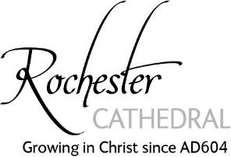

Purpose of Role: A voluntary role to help maintain and clean the brass in the Cathedral
Key Tasks:

- Cleaning the brass and ensuring that the corect materials are used

Person Specification
Attributes:
- Good communication skills
- Positive and enthusiastic
- Enjoys engaging with visitors
- Enjoys being part of a team
Time Commitment:
- Individual availability / agreed time as part of a team

Training:
- Undertake mandatory Safeguarding - Basic Awareness Training
- Follow the Cathedral Health and Safefty Guidelines

General duties of all Volunteers:
- Complying with, supporting and actively promoting Cathedral policies and practices at all times
- Attending such training and development opportunities as deemed necessary by Chapter to effectively fulfil the role and volunteer in compliance with Rochester Cathedral’s Health and Safety Policy at all times
- Complying with the Safeguarding guidelines and policy
- Read the Health and Safety Guidelines and sign the Health & Safety Document
- Being prepared to propose ideas for improvement and be prepared to receive performance related feedback
- Wearing lanyard with an identity badge and a Cathedral Safeguarding card
- Dressing appropriately

Key internal contacts:
Volunteer Manager: Sandy Struben
Head Verger: Colin Tolhurst
Prepared by: Sandy Struben, Volunteer Manager and Colin Tohurst , Head Verger.

Authorised by: Gordon Giles, Canon Chancellor (on behalf of Chapter)

